COMPUTER ENGINEERING DEPARTMENT

SUBMISSION REPORT
SUB: Cryptography and System Security

COURSE: T.E. Year: 2020-2021 Semester: VI
DEPT: Computer Engineering
SUBJECT CODE: CSC604 SUBMISSION DATE: 14/05/2021
==========================================================================================

Name: Amey Thakur | Roll No.: 50
Class: TE Comps B | ID: TU3F1819127

INDEX

Sr.No. | Particulars | Submitted/Not Submitted or Enter Marks received
Experiments
1 | Design and Implementation of a product cipher using Substitution and Transposition ciphers. | 9/10
2 | Implementation and analysis of RSA cryptosystem and Digital signature scheme using RSA/El Gamal. | 9/10
3 | For varying message sizes, test the integrity of the message using MD-5, SHA-1, and analyze the performance of the two protocols. Use crypt APIs. | 9/10
4 | Study the use of network reconnaissance tools like WHOIS, dig, traceroute, nslookup to gather information about networks and domain registrars. | 9/10
5 | Design a network and implement packet sniffing on telnet traffic using Wireshark. | 9/10
6 | Implement ARP spoofing using Ettercap. | 9/10
7 | Download and install Nmap. Use it with different options to scan open ports, perform OS fingerprinting, do a ping scan, TCP port scan, UDP port scan, Xmas scan etc. | 9/10
8 | Perform SQL injection on a vulnerable website. | 9/10
9 | Simulate DOS attack using Hoping, hping3 and other tools. | 9/10
10 | Explore the GPGwin tool and implement email security. | 8/10
Assignments
13 | Assignment No. 1 | 9/10
14 | Assignment No. 2 | 9/10
15 | Assignment No. 3 | Submitted
Quizzes
16 | CSS Quiz 1 | 10/10
17 | CSS Quiz 2 | 10/10
18 | CSS Quiz 3 | 10/10
19 | CSS Quiz 4 | 10/10
20 | CSS Quiz 5 | 10/10
21 | CSS Quiz 6 | 10/10
IAT
22 | IAT-1 | 18/20
23 | IAT-2 | Submitted
Exit Survey
24 | Course Exit Survey | Submitted
25 | Laboratory Exit Survey | Submitted

Signature: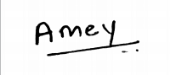

Experiments

CSS Experiment 1
Marks: (9/10)
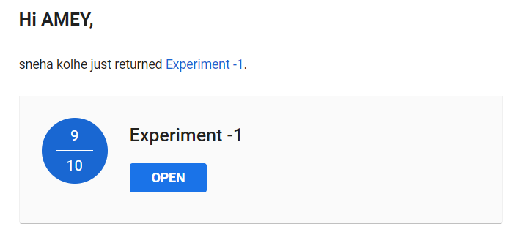

CSS Experiment 2
Marks: (9/10)
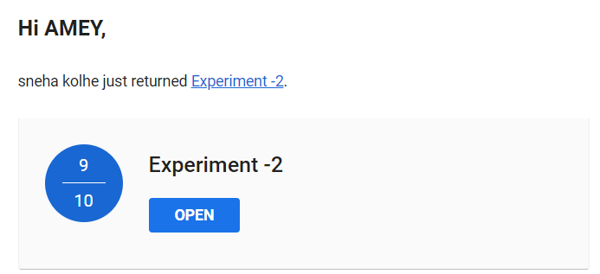

CSS Experiment 3
Marks: (9/10)
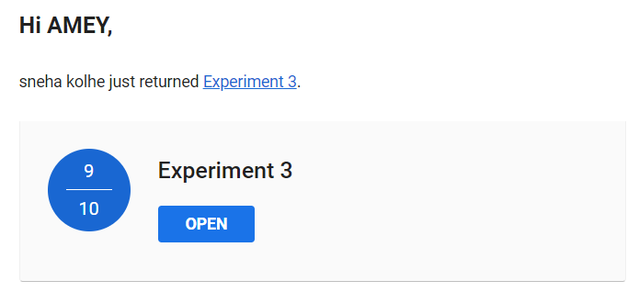

CSS Experiment 4
Marks: (9/10)
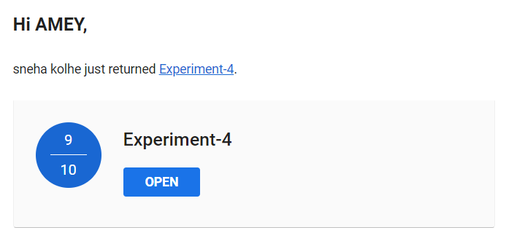

CSS Experiment 5
Marks: (9/10)
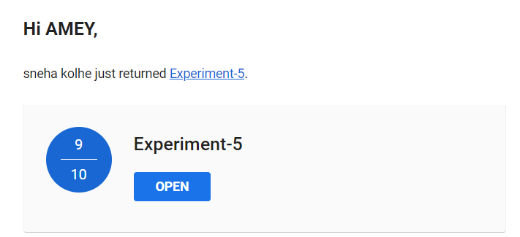

CSS Experiment 6
Marks: (9/10)
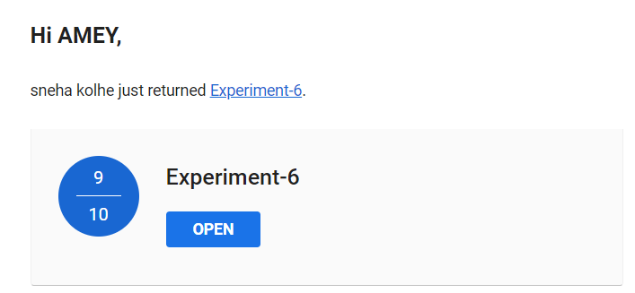

CSS Experiment 7
Marks: (9/10)
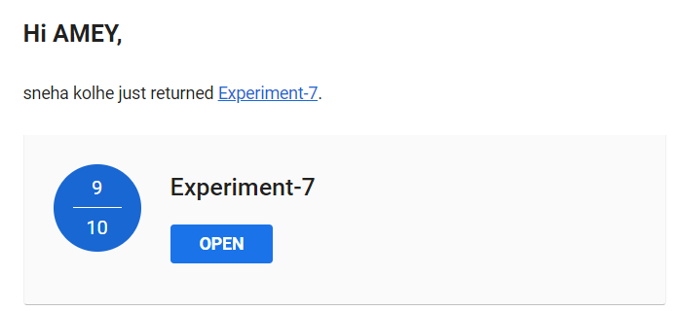

CSS Experiment 8
Marks: (9/10)
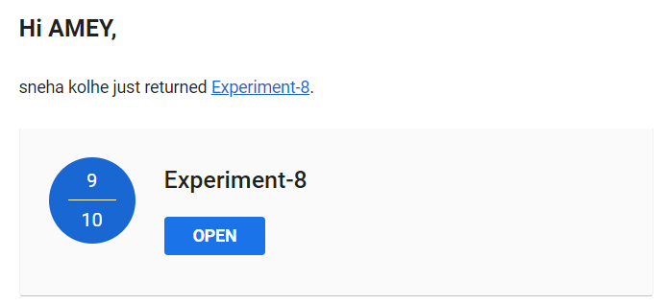

CSS Experiment 9
Marks: (9/10)
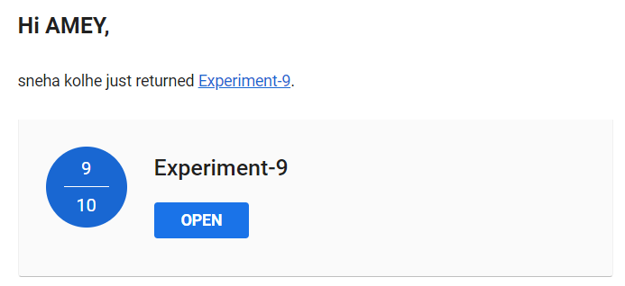

CSS Experiment 10
Marks: (8/10)
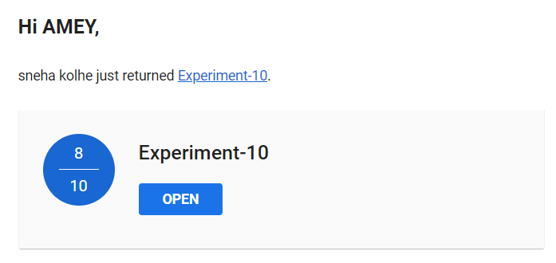

Assignments

CSS Assignment 1
Marks: (9/10)
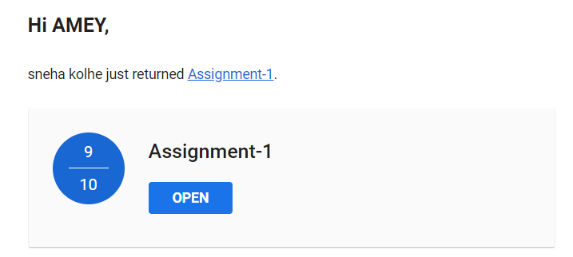

CSS Assignment 2
Marks: (9/10)
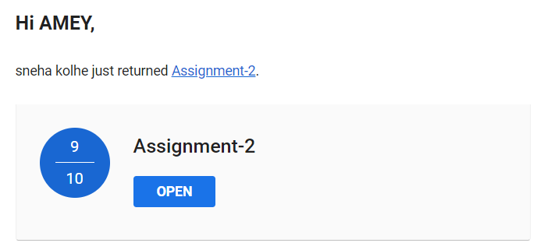

CSS Assignment 3
Marks: Not Received
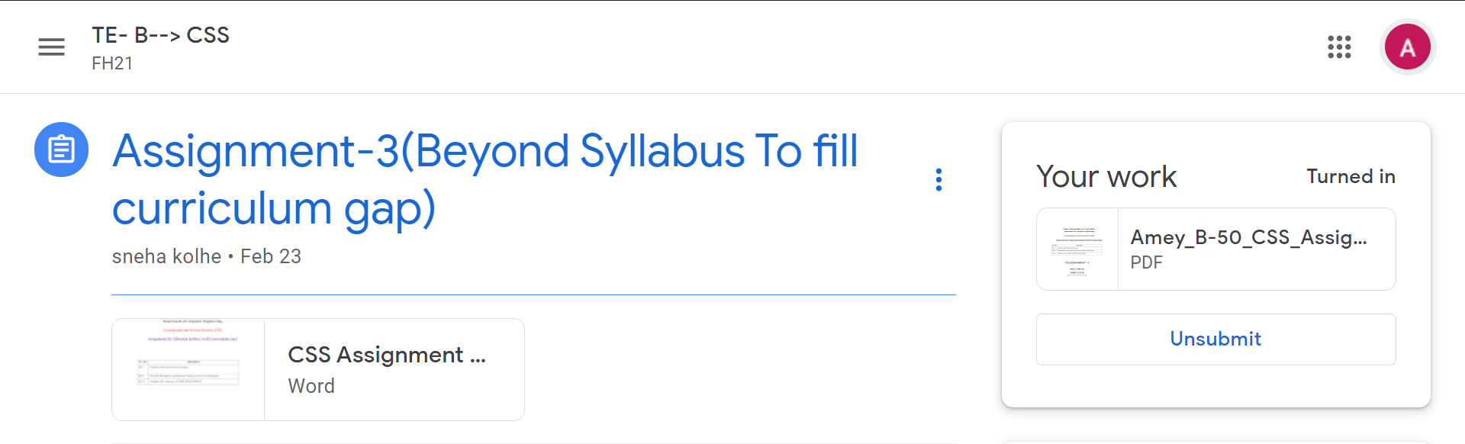

CSS Practice Test
Date: 14/05/2021
Marks: (46/50)

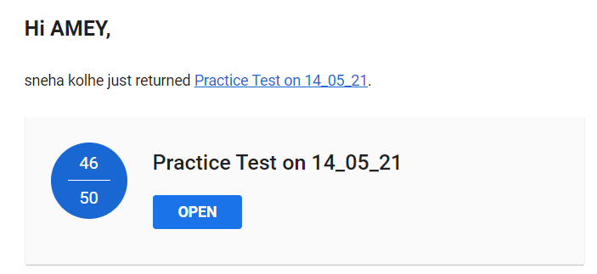

Quizzes

CSS Quiz 1
Marks: (10/10)
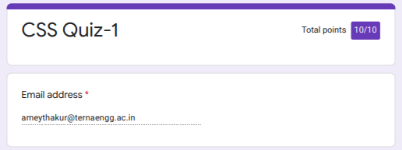
CSS Quiz 2
Marks: (10/10)
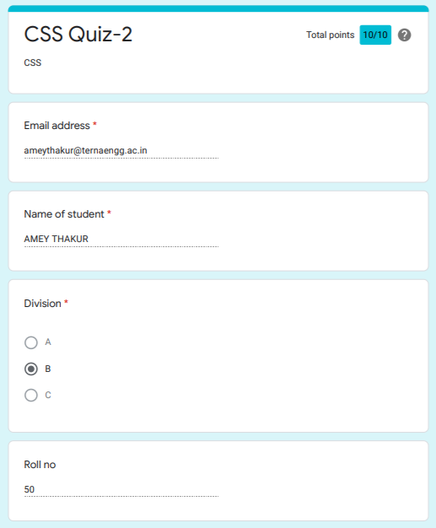
CSS Quiz 3
Marks: (10/10)
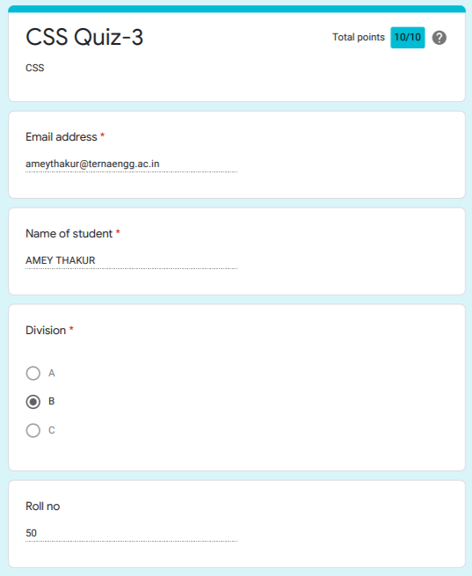

CSS Quiz 4
Marks: (10/10)
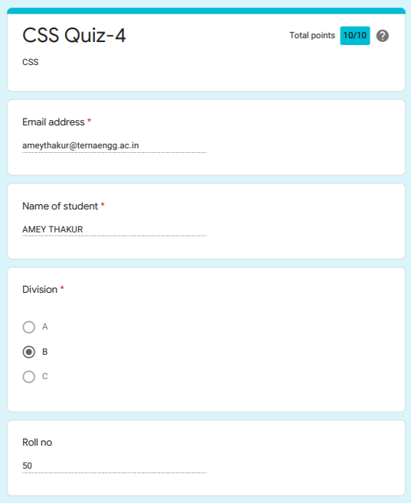

CSS Quiz 5
Marks: (10/10)
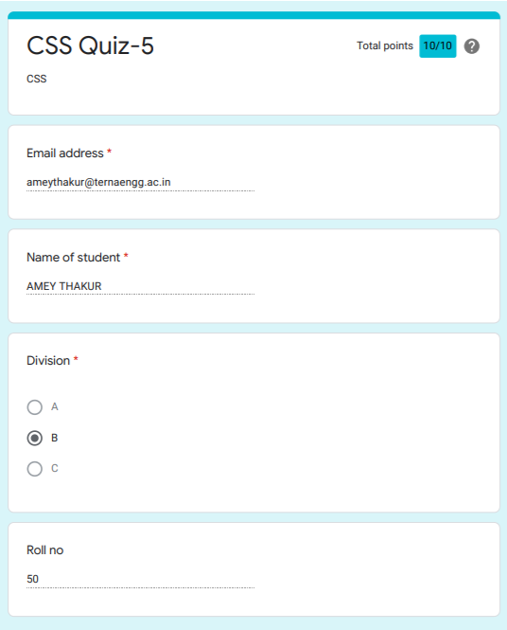

CSS Quiz 6
Marks: (10/10)

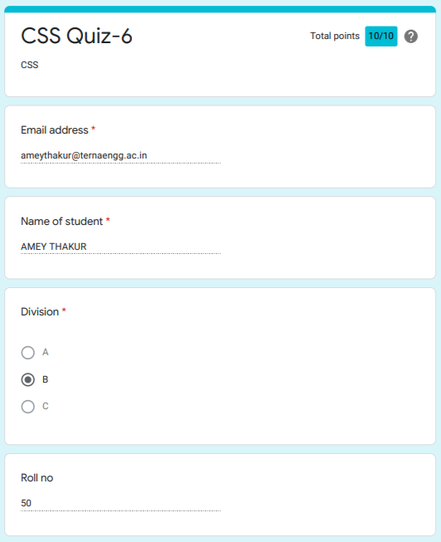

IAT

CSS IAT 1
Marks: (18/20)

IAT 1 Descriptive Answer Sheet
(First page attached)
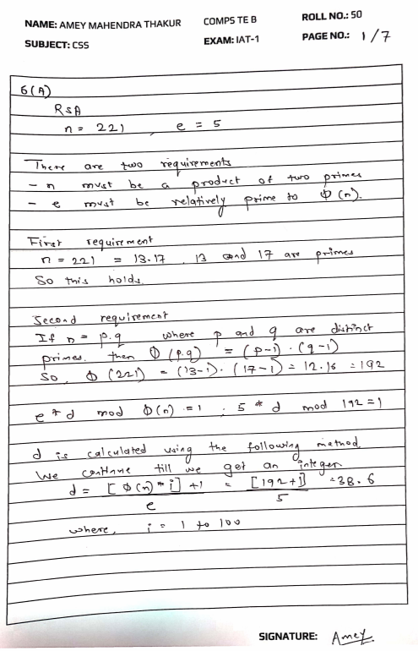
CSS IAT 2
Marks: Not Received

IAT 2 Descriptive Answer Sheet
(First page attached)
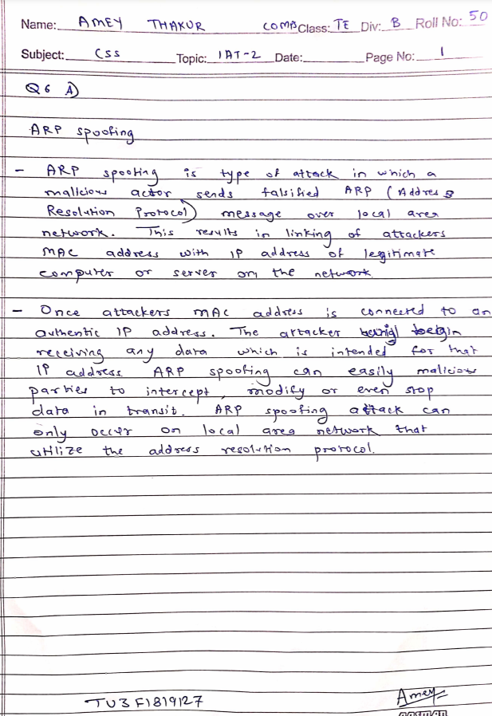
Exit Survey

CSS Course Exit survey
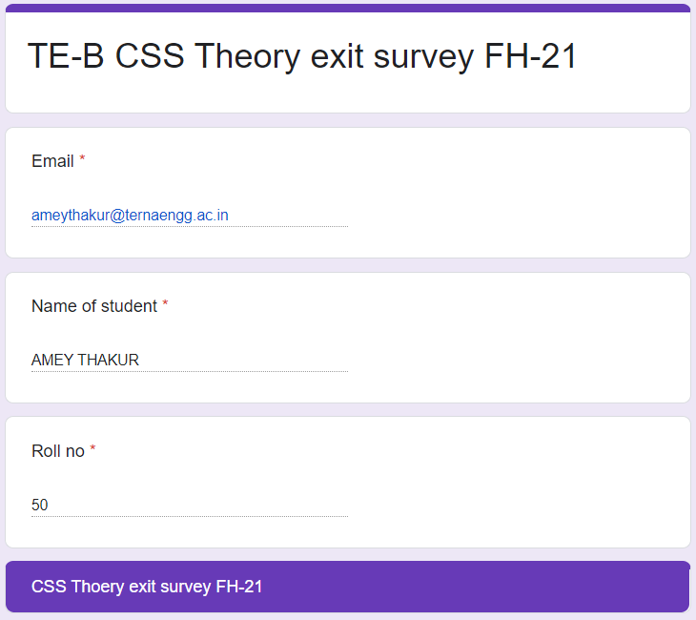

CSS Laboratory Exit Survey
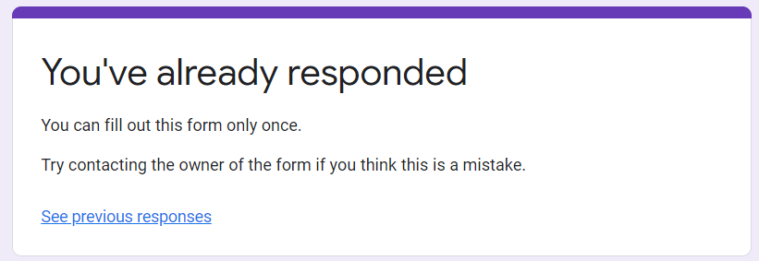
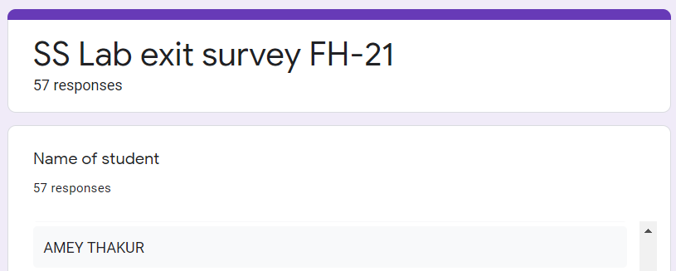
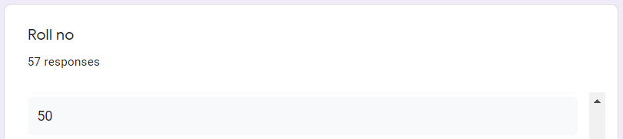
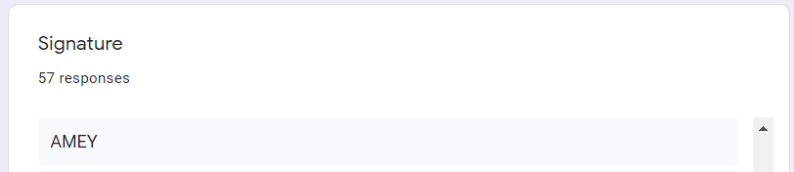

Google Classroom Submission Report
